SQL Olympic Project

Purpose:

Practice my SQL skillset using the Olympic dataset. SQL skills are valuable to employers

Overview:

Olympics are the one most exciting and entertaining events during the Summer and Winter. They originated in Greece and have been going on since 1896. It is wonderful to watch athletes from 200 countries worldwide show off their athletic abilities and skillset.

Dataset:

The dataset comprises of 120 years of both summer and winter Olympics from 1896 through 2012. The summer Olympics are through 2012 while the winter are through 2014. This dataset was downloaded from the Kaggle website. It consists of three tables which are the country dictionary, summer Olympics and winter Olympics.

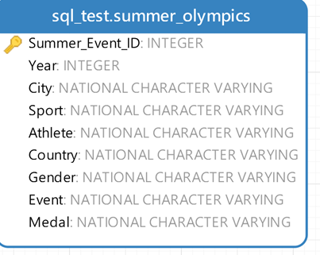 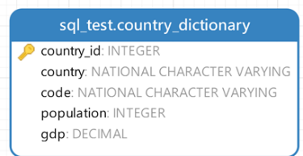

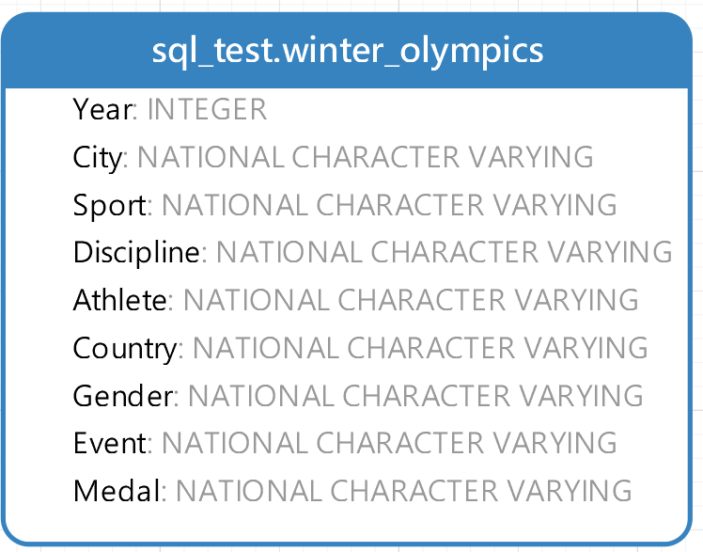

Goal:

Determine how the Olympics have changed over time by answering the following questions:

1. How many Summer Olympic games were there overall?

Summer Games

select count(*) as tot_games from (

select distinct Year

from summer_olympics) as a

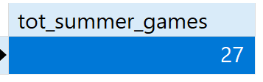

1. How many nations participated in each of the Summer olympics?

The query for getting number of nations in each of the Summer Olympics

Select Year, count(distinct(country)) as country_count

from summer_olympics

group by Year

order by 1;

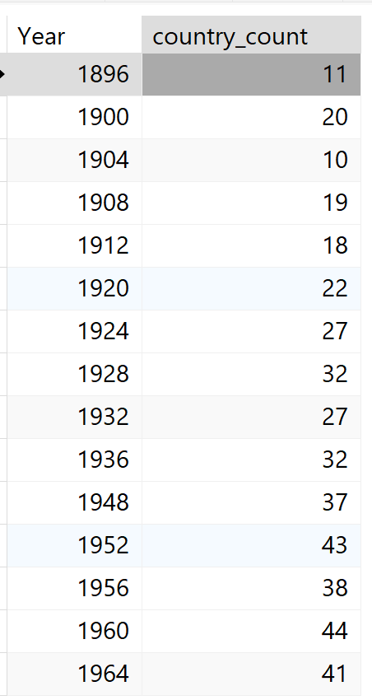

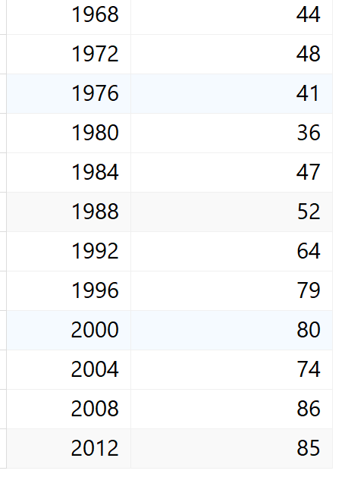

1. Which Country won the most medals breakdown overall?

Summer Olympics

Sorted by most medals by the gold medals

with gold as (

select Country, count(Medal) as gold_medal_cnt

from summer_olympics where Medal = 'Gold'

group by Country ),

silver as (

select Country, count(Medal) as silver_medal_cnt from summer_olympics

where Medal = 'Silver'

group by Country),

bronze as (

select Country, count(Medal) as bronze_medal_cnt from summer_olympics

where Medal = 'Bronze'

group by Country)

select a.Country, a.gold_medal_cnt as gold_count, b.silver_medal_cnt as silver_cnt, c.bronze_medal_cnt as bronze_cnt

from gold as a

inner join silver as b

on a.Country = b.Country

join bronze as c

on a.Country = c.Country

order by 2 desc

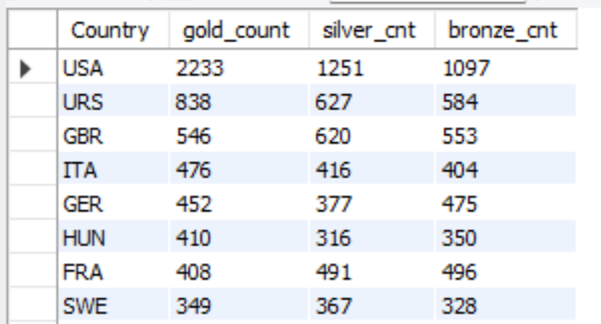

1. What are the top four sports with the most male participants in the 2012 games? Female participants?

Determines highest male participants

select Sport, count(*) as male_pop_sports

from summer_olympics

where Gender = "Men" and Year = "2012"

group by Sport

order by 2 desc

limit 4;

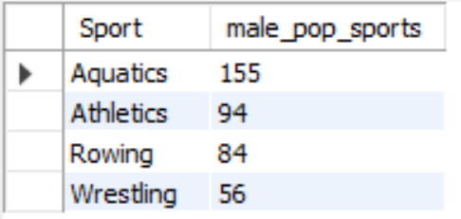

Determines highest female participants

select Sport, count(*) as female_pop_sports

from summer_olympics

where Gender = "Women" and Year = "2012"

group by Sport

order by 2 desc

limit 4;

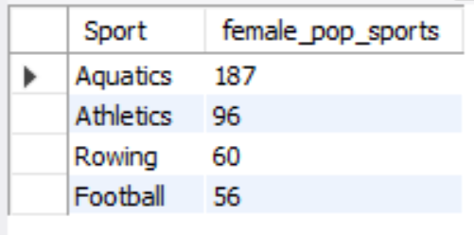

1. What are the top 3 athletes with the most gold medals in the 2012 summer games?

select Year, Athlete, count(Medal) as gold_medal_count

from summer_olympics

where Medal = "Gold" and Year = "2012"

group by Athlete

Order by 3 desc

limit 3;

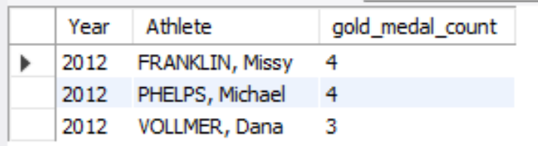

1. In which summer games did India win the highest number of medals?

select Year, Country, MAX(total_medal_count) as max_medal_count

from (

select Year, Country, count(Medal) as total_medal_count

from summer_olympics

where Country = "Ind"

group by Year, Country

) as medal_counts group by Year, Country

order by max_medal_count DESC

limit 1;

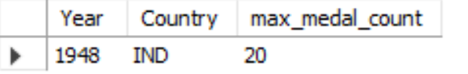

1. Sort by the number of golds won by India in the Summer games in descending order:

select Year, Country, count(Medal) as gold_medal_count

from summer_olympics

where Country = "Ind" and Medal = "Gold"

Group by Year

order by gold_medal_count desc;

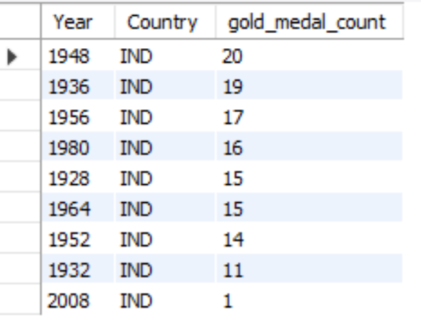

1. Determine the sports that India won the most medals in:

select distinct Sport, count(Medal) as tot_medal_cnt

from summer_olympics

where Country = 'Ind'

group by Sport

order by tot_medal_cnt desc

limit 3;

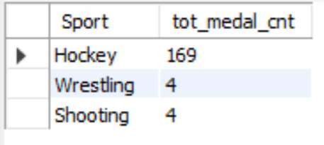

1. Determine the sports that India won the most gold medals in:

select distinct Sport, count(Medal) as tot_gold_cnt

from summer_olympics

where Country = 'Ind' and Medal = "Gold"

group by Sport, Medal

order by tot_gold_cnt desc;

